**NAME: TASMAI SHELKE**

**CLASS: MSC. CS PART 1**

**SEAT NUMBER: 31031522032**

**HUMAN-COMPUTER**

**INTERACTION**

**PRACTICAL JOURNAL**

INDEX

| **Practical No.** | **Name** | **Page no.** |
| --- | --- | --- |
| 1 | Building a Graphical User Interface depending on type of users of the  application | 3 |
| 2 | Take up any GUI and suggest changes to it based on principles of good interface design and redesign the GUI. | 13 |
| 3 | Design a navigator for a person new in a tourist city/ village using proper windows and screen controls. | 27 |
| 4 | Design a menu (horizontal and vertical) for an app that helps the user in planning his fitness training routine. | 31 |
| 5 | Design appropriate icons pertaining to a particular domain say for example Wedding Cards. | 37 |
| 6 | Case study on Web Interface | 43 |
| 7 | Case study on Mobile App Interface. | 45 |
| 8 | Case study on Desktop App Interface. | 47 |

**Practical 1**

**Building a Graphical User Interface depending on type of users of the application**

**1. A Food Delivery web page for customers (client side)**

**Code -**

**HTML-**

<meta charset="UTF-8">

<meta name="viewport" content="width=device-width, initial-scale=1.0">

<title>Food Delivery</title>

<link rel="stylesheet" href="https://use.fontawesome.com/releases/v5.14.0/css/all.css" integrity="sha384-HzLeBuhoNPvSl5KYnjx0BT+WB0QEEqLprO+NBkkk5gbc67FTaL7XIGa2w1L0Xbgc" crossorigin="anonymous">

<link rel="stylesheet" href="practical1.css">

<link rel="stylesheet" href="https://stackpath.bootstrapcdn.com/bootstrap/5.0.0-alpha1/css/bootstrap.min.css" integrity="sha384-r4NyP46KrjDleawBgD5tp8Y7UzmLA05oM1iAEQ17CSuDqnUK2+k9luXQOfXJCJ4I" crossorigin="anonymous">

<body>

<nav class="navbar navbar-expand-lg navbar-dark">

<div class="container-fluid">

<a class="navbar-brand" href="#">FOOD DELIVERY</a>

<button class="navbar-toggler" type="button" data-toggle="collapse" data-target="#navbarNavDropdown" aria-controls="navbarNavDropdown" aria-expanded="false" aria-label="Toggle navigation">

<span class="navbar-toggler-icon"></span>

</button>

<div class="collapse navbar-collapse" id="navbarNavDropdown">

<ul class="navbar-nav ml-auto ">

<li class="nav-item dropdown">

<a class="nav-link dropdown-toggle " href="#" id="navbarDropdownMenuLink" role="button" data-toggle="dropdown" aria-expanded="false">

EN

</a>

<ul class="dropdown-menu" aria-labelledby="navbarDropdownMenuLink">

<li>

<h6 class="dropdown-header">Language</h6>

</li>

<li><a class="dropdown-item" href="#">SP</a></li>

<li><a class="dropdown-item" href="#">FR</a></li>

<li><a class="dropdown-item" href="#">DE</a></li>

</ul>

</li>

<li class="nav-item ml-lg-3">

<a class="nav-link text-light" href="#">Contact</a>

</li>

<li class="nav-item">

<a class="nav-link text-light" href="#">Log In</a>

</li>

<li class="nav-item dropdown ml-lg-3 ">

<a class="nav-link dropdown-toggle text-light d-inline-block bg-orange rounded p-1 p-lg-2" href="#" id="navbarDropdownMenuLink" role="button" data-toggle="dropdown" aria-expanded="false">

Sign Up

</a>

<ul class="dropdown-menu dropdown-menu-lg-right p-5 sign__container" aria-labelledby="navbarDropdownMenuLink">

<h1 class="h4 mb-3 font-weight-normal text-center">Please sign in</h1>

<label for="inputEmail" class="sr-only">Email address</label>

<input type="email" id="inputEmail" class="form-control" placeholder="Email address" required="" autofocus="">

<label for="inputPassword" class="sr-only ">Password</label>

<input type="password" id="inputPassword" class="form-control mb-2" placeholder="Password" required="">

<div class="checkbox mb-4">

<label>

<input type="checkbox" value="remember-me"> Remember me

</label>

</div>

<button class="btn btn-lg bg-orange btn-block text-light" type="submit">Sign in</button>

</ul>

</li>

</ul>

</div>

</div>

</nav>

<main class="container-fluid cover ">

<div class="row align-items-center justify-content-center justify-content-xl-start vh-80">

<div class="col col-sm-7 text-center text-xl-left col-xl-4 offset-xl-2">

<h1 class="mb-4">Get food delivered on your doorstep</h1>

<p class="mb-5 subtitle-mb">Food, drinks and desserts available for delivery or pickup</p>

<div class="input-group mb-3 shadow">

<input type="text" class="form-control" placeholder="Enter delivery address" aria-label="Search" aria-describedby="basic-addon1">

<div class="input-group-prepend">

<button class="btn bg-orange text-light text-uppercase p-3" type="button">Find food</button>

</div>

</div>

<!-- <form class="d-flex shadow">

<input class="form-control " type="search" placeholder="Enter delivery address" aria-label="Search">

<button class="btn bg-orange text-white ml-3 text-uppercase " type="submit">Find Food</button>

</form> -->

</div>

</div>

</main>

<footer class="page-footer font-small bg-light">

<div>

<div class="container-fluid">

<!-- Grid row-->

<div class="row py-4 d-flex align-items-center">

<!-- Grid column -->

<div class="col-md-7 col-lg-5 col-xl-4 text-center text-md-left mb-md-0 small">

<nav class="nav justify-content-center justify-content-md-start">

<a class="nav-link text-muted" href="#">Privacy Policy</a>

<a class="nav-link text-muted" href="#">Careers</a>

<a class="nav-link text-muted" href="#">About</a>

<a class="nav-link text-muted" href="#">Contact</a>

</nav>

</div>

<!-- Grid column -->

<div class="col-md-3 col-lg-4 col-xl-6 text-center text-md-left mb-md-0 small">

<div class="footer-copyright text-center text-black-50 pt-3 pb-2">© 2023

</div>

</div>

<!-- Grid column -->

<div class="col-md-2 col-lg-3 col-xl-2 text-center text-md-right">

<a href="#" class="text-dark">

<i class="fab fa-facebook-f white-text mx-2"> </i></a>

<a href="#" class="text-dark">

<i class="fab fa-twitter white-text mx-2"> </i></a>

<a href="#" class="text-dark">

<i class="fab fa-instagram white-text mx-2"> </i></a>

</div>

<!-- Grid column -->

</div>

<!-- Grid row-->

</div>

</div>

</footer>

**Css (styles)**-

.navbar {

background-color: #242e4c;

}

.cover {

background: url('https://img.freepik.com/free-photo/copy-space-italian-food-ingredients_23-2148551732.jpg');

background-repeat: no-repeat;

background-size: cover;

background-position: center center;

}

.server-side {

background: url('https://t3.ftcdn.net/jpg/02/21/40/16/360_F_221401603_6urJw6Di9KjlgcPgLfkdVLHtc5Q21aCx.jpg');

background-repeat: no-repeat;

background-size: cover;

background-position: center center;

}

.diff {

color:antiquewhite;

}

.bg-orange {

background-color: #ff6144!important;

}

.vh-80 {

min-height: 84vh;

}

.sign__container {

width: 60%;

}

@media (min-width: 1200px) {

.sign__container {

width: 350px;

}

.subtitle-mb{

margin-bottom: 5.5rem!important;

}

}

**Output** -

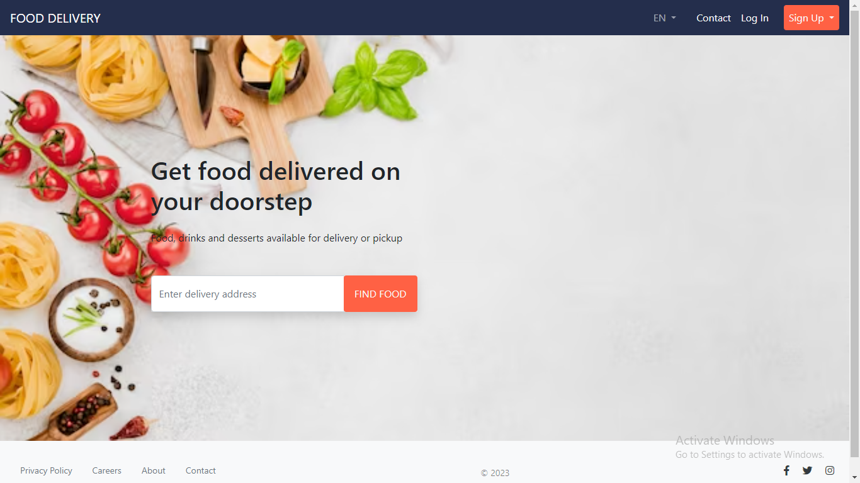

**2. Same food delivery web page but for restaurants (server side)**

**Code -**

<meta charset="UTF-8">

<meta name="viewport" content="width=device-width, initial-scale=1.0">

<title>Food Delivery</title>

<link rel="stylesheet" href="https://use.fontawesome.com/releases/v5.14.0/css/all.css" integrity="sha384-HzLeBuhoNPvSl5KYnjx0BT+WB0QEEqLprO+NBkkk5gbc67FTaL7XIGa2w1L0Xbgc" crossorigin="anonymous">

<link rel="stylesheet" href="practical1.css">

<link rel="stylesheet" href="https://stackpath.bootstrapcdn.com/bootstrap/5.0.0-alpha1/css/bootstrap.min.css" integrity="sha384-r4NyP46KrjDleawBgD5tp8Y7UzmLA05oM1iAEQ17CSuDqnUK2+k9luXQOfXJCJ4I" crossorigin="anonymous">

<body>

<nav class="navbar navbar-expand-lg navbar-dark">

<div class="container-fluid">

<a class="navbar-brand" href="#">FOR RESTAURANTS</a>

<button class="navbar-toggler" type="button" data-toggle="collapse" data-target="#navbarNavDropdown" aria-controls="navbarNavDropdown" aria-expanded="false" aria-label="Toggle navigation">

<span class="navbar-toggler-icon"></span>

</button>

<div class="collapse navbar-collapse" id="navbarNavDropdown">

<ul class="navbar-nav ml-auto ">

<li class="nav-item dropdown">

<a class="nav-link dropdown-toggle " href="#" id="navbarDropdownMenuLink" role="button" data-toggle="dropdown" aria-expanded="false">

EN

</a>

<ul class="dropdown-menu" aria-labelledby="navbarDropdownMenuLink">

<li>

<h6 class="dropdown-header">Language</h6>

</li>

<li><a class="dropdown-item" href="#">SP</a></li>

<li><a class="dropdown-item" href="#">FR</a></li>

<li><a class="dropdown-item" href="#">DE</a></li>

</ul>

</li>

<li class="nav-item ml-lg-3">

<a class="nav-link text-light" href="#">Verify</a>

</li>

<li class="nav-item">

<a class="nav-link text-light" href="#">Log In</a>

</li>

<li class="nav-item dropdown ml-lg-3 ">

<a class="nav-link dropdown-toggle text-light d-inline-block bg-orange rounded p-1 p-lg-2" href="#" id="navbarDropdownMenuLink" role="button" data-toggle="dropdown" aria-expanded="false">

Sign Up

</a>

<ul class="dropdown-menu dropdown-menu-lg-right p-5 sign__container" aria-labelledby="navbarDropdownMenuLink">

<h1 class="h4 mb-3 font-weight-normal text-center">Please sign in</h1>

<label for="inputEmail" class="sr-only">Email address</label>

<input type="email" id="inputEmail" class="form-control" placeholder="Email address" required="" autofocus="">

<label for="inputPassword" class="sr-only ">Password</label>

<input type="password" id="inputPassword" class="form-control mb-2" placeholder="Password" required="">

<div class="checkbox mb-4">

<label>

<input type="checkbox" value="remember-me"> Remember me

</label>

</div>

<button class="btn btn-lg bg-orange btn-block text-light" type="submit">Sign in</button>

</ul>

</li>

</ul>

</div>

</div>

</nav>

<main class="container-fluid cover server-side">

<div class="row align-items-center justify-content-center justify-content-xl-start vh-80">

<div class="col col-sm-7 text-center text-xl-left col-xl-4 offset-xl-2">

<h1 class="mb-4">Partner with us</h1>

<p class="mb-5 subtitle-mb">Serve your delicacys to our customers with upto 85% comission</p>

<div class="input-group mb-3 shadow">

<input type="text" class="form-control" placeholder="Enter your business email" aria-label="Search" aria-describedby="basic-addon1">

<div class="input-group-prepend">

<button class="btn bg-orange text-light text-uppercase p-3" type="button">Verify and begin</button>

</div>

</div>

<!-- <form class="d-flex shadow">

<input class="form-control " type="search" placeholder="Enter delivery address" aria-label="Search">

<button class="btn bg-orange text-white ml-3 text-uppercase " type="submit">Find Food</button>

</form> -->

</div>

</div>

</main>

<footer class="page-footer font-small bg-light">

<div>

<div class="container-fluid">

<!-- Grid row-->

<div class="row py-4 d-flex align-items-center">

<!-- Grid column -->

<div class="col-md-7 col-lg-5 col-xl-4 text-center text-md-left mb-md-0 small">

<nav class="nav justify-content-center justify-content-md-start">

<a class="nav-link text-muted" href="#">Privacy Policy</a>

<a class="nav-link text-muted" href="#">Careers</a>

<a class="nav-link text-muted" href="#">About</a>

<a class="nav-link text-muted" href="#">Contact</a>

</nav>

</div>

<!-- Grid column -->

<div class="col-md-3 col-lg-4 col-xl-6 text-center text-md-left mb-md-0 small">

<div class="footer-copyright text-center text-black-50 pt-3 pb-2">© 2023

</div>

</div>

<!-- Grid column -->

<div class="col-md-2 col-lg-3 col-xl-2 text-center text-md-right">

<a href="#" class="text-dark">

<i class="fab fa-facebook-f white-text mx-2"> </i></a>

<a href="#" class="text-dark">

<i class="fab fa-twitter white-text mx-2"> </i></a>

<a href="#" class="text-dark">

<i class="fab fa-instagram white-text mx-2"> </i></a>

</div>

<!-- Grid column -->

</div>

<!-- Grid row-->

</div>

</div>

</footer>

**Output -**

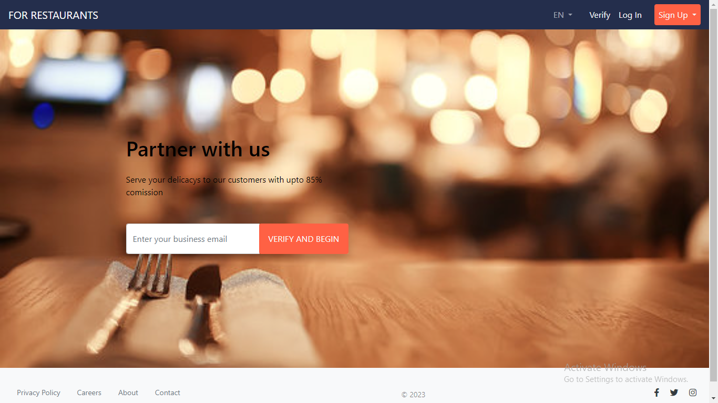

**Practical 2**

**Take up any GUI and suggest changes to it based on principles of good interface design and redesign the GUI**

**Code -**

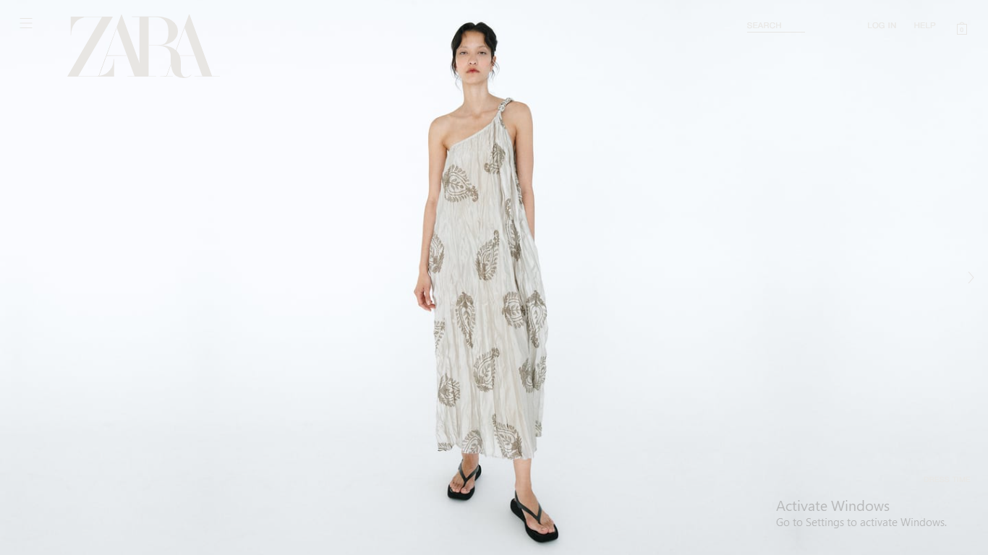

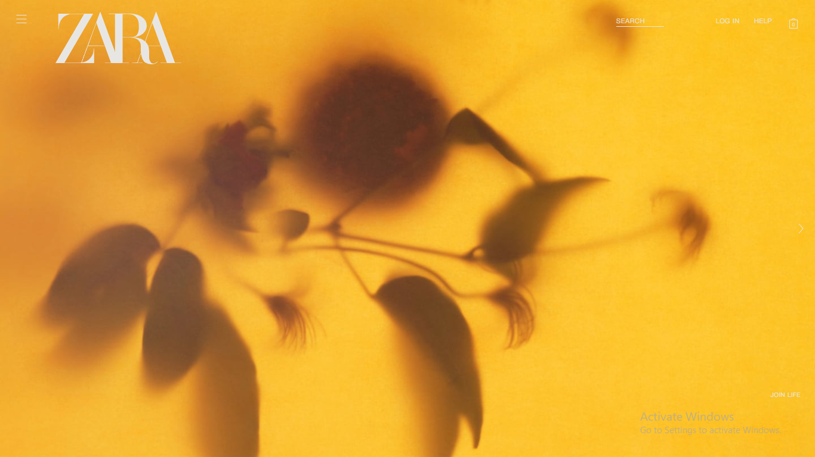

**Things to improve**

1. **Quirky aesthetic**:

* Zara has adopted a clever marketing tactic with their quirky way to display products to gain attention online. However, the truth is this bizarre campaign imagery has sent many shoppers into a state of confusion.

1. **Poor Usability**:

* The font colour is blending with the background, which is not a good design implementation.
* Navigating on the web page becomes difficult when there are no precise indicators.
* Colour scheme usage goes against the accessibility rules of ux design.
* Font size is too small.

**Corrected and Updated Version -**

**HTML-**

<meta charset="UTF-8">

<meta name="viewport" content="width=device-width, initial-scale=1.0">

<title>ZARA INDIA</title>

<link rel="stylesheet" href="practical2.css">

<body>

<div id="app">

<header>

<div class="header_content container">

<logo><img src="https://res.cloudinary.com/coderabbi/image/upload/v1641571711/zara-Logo_vopc32.png" alt=""></logo>

<nav>

<div class="link"><a href="#">New Arrivals</a></div>

<div class="link"><a href="#">Shop</a></div>

<div class="link"><a href="#">Blog</a></div>

<div class="link"><a href="#">About</a></div>

<div class="link"><a href="#">Cart</a></div>

</nav>

</div>

</header>

<section class="hero">

<div class="hero_content container">

<div class="hero-description">

<h1 class="hero-text">New Year Season</h1>

<h2 class="hero-text">Bringing fashion back to its original and classic form</h2>

<p class="hero-text">Fashion designers are reviving historical styles and honoring the art of garment design to create a new fashion revolution</p>

</div>

<img src="https://static.zara.net/photos///2023/V/0/1/p/6840/052/400/18/w/563/6840052400_1_1_1.jpg?ts=1681244436249" alt="" class="hero-1">

<img src="https://static.zara.net/photos///2023/V/0/1/p/6929/301/611/2/w/563/6929301611_1_1_1.jpg?ts=1681309443120" alt="" class="hero-2">

</div>

</section>

<section class="classics-top">

<img src="https://res.cloudinary.com/coderabbi/image/upload/v1641571717/classics-top_tmajmr.png" alt="" class="classics-top-image">

<div class="classics-top-content container">

<h1>Back to the Classics</h1>

<div class="classics-card">

<h2>You're not a fashion victim</h2>

<p>The clothes that connect you to the person you are inside. The Perfect Blend of Common-sense Classic & Contemporary</p>

</div>

</div>

</section>

<div class="collection container">

<card>

<img src="https://res.cloudinary.com/coderabbi/image/upload/v1641571717/collection-1_xc30u0.png" alt="">

<p>Limited edition wool blend cape</p>

<div class="link"><a href="#">Shop the collection</a></div>

</card>

<card>

<img src="https://res.cloudinary.com/coderabbi/image/upload/v1641571716/collection-2_ryxnes.png" alt="">

<p>Reversible also Printed Kimono</p>

<div class="link"><a href="#">Shop the collection</a></div>

</card>

<card>

<img src="https://res.cloudinary.com/coderabbi/image/upload/v1641571714/collection-3_wygqb2.png" alt="">

<p>Long trench wool coat with hood</p>

<div class="link"><a href="#">Shop the collection</a></div>

</card>

</div>

<section class="classics-bottom">

<div class="classics-bottom-content container">

<h1>Back to the Classics</h1>

<p>The clothes that connect you to the person you are inside. The Perfect Blend of Common-sense Classic & Contemporary</p>

</div>

<div class="classics-bottom-images">

<img src="https://res.cloudinary.com/coderabbi/image/upload/v1641571712/classics-bottom-1_orv8uk.png" alt="">

<img src="https://res.cloudinary.com/coderabbi/image/upload/v1641571712/classics-bottom-2_wnjoyq.png" alt="">

<img src="https://res.cloudinary.com/coderabbi/image/upload/v1641571713/classics-bottom-3_vpe9ds.png" alt="">

</div>

</section>

<footer>

<div class="footer-content container">

<img src="https://res.cloudinary.com/coderabbi/image/upload/v1641571711/zara-Logo_vopc32.png" alt="">

<about>

<h3>About Us</h3>

<div class="link"><a href="#">Our Story</a></div>

<div class="link"><a href="#">Memory</a></div>

<div class="link"><a href="#">Terms & Privacy</a></div>

</about>

<div class="customer">

<h3>Customer Care</h3>

<div class="link"><a href="#">FAQ</a></div>

<div class="link"><a href="#">Contact</a></div>

<div class="link"><a href="#">Shipping</a></div>

</div>

<follow>

<h3>Follow Us</h3>

<div class="link"><a href="#">Instagram</a></div>

<div class="link"><a href="#">Twitter</a></div>

<div class="link"><a href="#">Linkedin</a></div>

</follow>

<div class="subscribe">

<h3>Stay for future updates from ZARA</h3>

<div class="subscribe-box">

<input type="text" placeholder="Enter your email">

<div class="button"><button>Subscribe</button></div>

</div>

</div>

</div>

</footer>

</div>

</body>

**CSS-**

*, *::before, *::after {

margin: 0;

padding: 0;

box-sizing: border-box;

transition: all 500ms ease-in-out;

scroll-behavior: smooth;

}

html, body {

height: 100vh;

margin: 0;

}

body {

background: #EAEAEA;

font-family: Wensley;

}

#app {

width: 100%;

width: max(100%, 1100px);

height: 100%;

/* overflow: scroll; */

}

.container {

width: 88.88%;

margin: 0 auto;

}

a {

display: block;

color: inherit;

}

header {

height: 13%;

height: clamp(4rem, 13%, 7rem);

display: flex;

}

.header_content {

display: flex;

justify-content: space-between;

align-items: center;

}

nav {

width: 540px;

display: flex;

justify-content: space-between;

align-items: center;

}

nav a {

text-decoration: none;

font-size: 1.2em;

position: relative;

}

nav a::after {

content: "";

position: absolute;

bottom: -20%;

/* left: 0;

width: 50%; */

height: 2px;

background: #000;

}

nav .link:hover a::after {

animation: underline 700ms cubic-bezier(.85,.23,.4,1.13);

}

@keyframes underline {

0% {

left: 0;

width: 0;

}

45% {

width: 100%;

}

55% {

width: 100%;

}

100% {

right: 0;

width: 0;

}

}

nav .link:last-child a {

background: #000;

color: #fff;

padding: .5em .9em;

border-radius: 4px;

position: relative;

}

nav .link:last-child a::after {

content: "";

position: absolute;

top: 0;

height: 100%;

background: #fff6;

}

nav .link:last-child:hover a::after {

animation: fill 700ms cubic-bezier(.85,.23,.4,1.13);

}

.hero {

margin-top: 3%;

width: 100%;

height: clamp(733px, 87%, 960px);

}

.hero_content {

height: 85%;

position: relative;

}

.hero-description {

height: 100%;

display: flex;

flex-direction: column;

justify-content: space-between;

}

.hero-text {

display: flex;

align-items: center;

z-index: 1;

}

.hero h1 {

width: 50%;

height: 40.25%;

font-size: clamp(6.3em, 7.9em, 9vw);

line-height: .95em;

}

.hero h2 {

width: 48%;

height: 35%;

font-size: clamp(3.5em, 4.2vw, 4.2em);

font-weight: 500;

}

.hero p {

width: 38.125%;

height: 15%;

font-size: 1.36em;

line-height: 1.4em;

color: #000b;

}

.hero img {

position: absolute;

object-fit: cover;

}

.hero-1 {

top: 0;

right: clamp(40vh, 39%, 23vw);

height: 100%;

}

.hero-2 {

right: 0;

height: 75.305%;

top: 50%;

transform: translateY(-50%);

}

.classics-top {

margin-top: 7%;

width: 100%;

height: 800px;

position: relative;

}

.classics-top-content {

position: absolute;

top: 0;

left: 0;

right: 0;

bottom: 0;

display: flex;

align-items: flex-end;

}

.classics-top img {

width: 100%;

object-fit: cover;

}

.classics-top h1 {

width: 57.66%;

margin-bottom: 7.5%;

font-size: 7.9em;

line-height: .95em;

}

.classics-card {

width: 42.34%;

height: 55.56%;

padding: 2.5em;

background: #EAEAEA;

}

.classics-card h2 {

font-size: 4em;

}

.classics-card p {

font-size: 1.5em;

}

.collection {

margin-top: 5%;

height: 700px;

display: flex;

justify-content: space-between;

align-items: flex-end;

}

card {

width: 28.6%;

height: 79.33%;

display: flex;

flex-direction: column;

/* justify-content: space-between; */

margin-bottom: 5%;

}

card:nth-of-type(2) {

margin-bottom: 10%;

}

card p {

margin-top: 1em;

font-size: 2em;

}

card a {

margin-top: .4em;

font-size: 1.25em;

width: fit-content;

position: relative;

}

card a::after {

content: "";

position: absolute;

bottom: -20%;

height: 2px;

background: #ce964f;

}

card:first-of-type a::after {

background: #beb8a8;

}

card:last-of-type a::after {

background: #000;

}

card .link:hover a::after {

animation: underline 700ms cubic-bezier(.85,.23,.4,1.13);

}

.classics-bottom {

margin-top: 7%;

width: 100%;

height: 603px;

position: relative;

}

.classics-bottom-content {

position: absolute;

top: 0;

left: 0;

right: 0;

bottom: 0;

display: flex;

justify-content: space-between;

align-items: flex-start;

z-index: 1;

}

.classics-bottom h1 {

width: 57.66%;

margin-top: 3rem;

font-size: 7.9em;

line-height: .95em;

}

.classics-bottom p {

margin-top: 3.3rem;

width: 29%;

font-size: 1.3em;

}

.classics-bottom-images {

width: 100%;

display: flex;

position: absolute;

bottom: 0;

}

.classics-bottom-images img {

width: 33.33%;

}

footer {

height: 40vh;

display: flex;

align-items: center;

}

.footer-content {

height: 40%;

display: flex;

justify-content: space-between;

}

footer img {

align-self: flex-start;

}

footer h3 {

font-weight: 900;

font-size: 1.2rem;

}

footer a {

width: fit-content;

color: #000b;

text-decoration: none;

position: relative;

}

footer a::after {

content: "";

position: absolute;

bottom: -20%;

height: 2px;

background: #000b;

}

footer .link:hover a::after {

animation: underline 700ms cubic-bezier(.85,.23,.4,1.13);

}

footer img ~ * {

display: flex;

flex-direction: column;

justify-content: space-between;

}

.subscribe {

display: block;

width: 30%;

}

.subscribe-box {

margin-top: 1em;

width: 100%;

display: flex;

}

.subscribe-box input {

height: 3rem;

width: 70%;

padding: .4em;

font-size: 1.14em;

font-family: inherit;

outline: none;

border: none;

}

.subscribe-box input::placeholder {

color: #0005;

}

.subscribe-box .button {

width: 30%;

display: flex;

}

button {

font-size: 1.14em;

font-family: inherit;

color: #fff;

background: #000;

border-radius: 5px;

outline: none;

border: none;

position: relative;

}

.subscribe-box button::after {

content: "";

position: absolute;

top: 0;

height: 100%;

background: #fff4;

}

.subscribe-box .button:hover button::after {

animation: fill 700ms cubic-bezier(.85,.23,.4,1.13);

}

@keyframes fill {

0% {

left: 0;

width: 0;

}

45% {

width: 100%;

}

55% {

width: 100%;

}

100% {

right: 0;

width: 0;

}

}

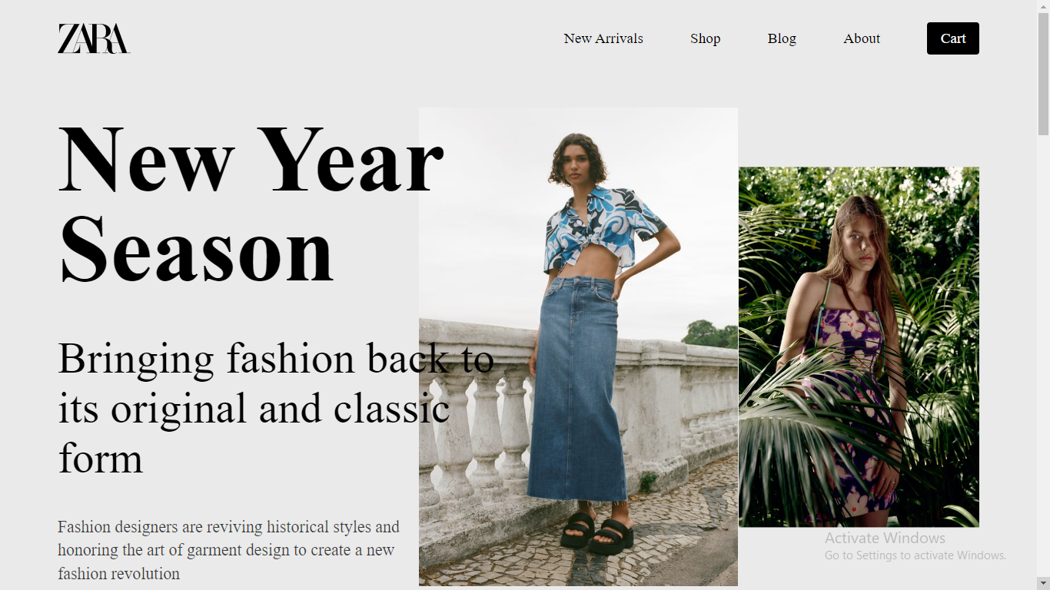

**Practical 3**

**Design a navigator for a person new in a tourist city/ village using proper windows and screen controls.**

**Code -**

**HTML -**

<!DOCTYPE html>

<html lang="en">

<head>

<meta name="viewport" content="width=device-width, initial-scale=1, shrink-to-fit=no">

<meta charset="UTF-8">

<title>Tour India</title>

<link rel="icon" href="./img/j.jpg" type="image/jpg">

<link href="https://fonts.googleapis.com/css?family=Poppins:100,200,400,300,500,600,700" rel="stylesheet">

<link rel="stylesheet" href="main.css">

</head>

<body>

<div class="protfolio-wrap">

<header class="default-header">

<nav class="navbar navbar-expand-lg navbar-light">

<div class="container">

<a class="navbar-brand" href="index.html">

<img src="img/logo.png" alt="">

</a>

<button class="navbar-toggler" type="button" data-toggle="collapse" data-target="#navbarSupportedContent" aria-controls="navbarSupportedContent" aria-expanded="false" aria-label="Toggle navigation">

<span class="text-white lnr lnr-menu"></span>

</button>

<div class="collapse navbar-collapse justify-content-end align-items-center" id="navbarSupportedContent">

<ul class="navbar-nav">

<li><a href="./Pages-inside/blog.html">Blogs</a></li>

<li><a href="#portfolio">Places</a></li>

<li><a href="#service">Services</a></li>

<li><a href="./Pages-inside/About.html">About Us</a></li>

</ul>

</div>

</div>

</nav>

</header>

<div class="filters">

<ul>

<li class="active" data-filter="*">All</li>

<li data-filter=".corporate">North</li>

<li data-filter=".personal">Central</li>

<li data-filter=".agency">North-Eastern</li>

<li data-filter=".portal">South</li>

</ul>

</div>

<div class="filters-content">

<div class="row grid">

<div class="single-portfolio col-sm-4 all corporate">

<div class="item">

<img src="img/p1.jpg" alt="Work 1">

<div class="p-inner">

<h4><a href="./Pages-inside/GoldenTemple-Info.html">Golden Temple</a></h4>

<div class="cat">Punjab</div>

</div>

</div>

</div>

<div class="single-portfolio col-sm-4 all personal">

<div class="item">

<img src="img/p2.jpg" alt="Work 1">

<div class="p-inner">

<h4>Gwalior Fort</h4>

<div class="cat">Madhya Pradesh</div>

</div>

</div>

</div>

<div class="single-portfolio col-sm-4 all agency">

<div class="item">

<img src="img/p9.jpg" alt="Work 1">

<div class="p-inner">

<h5>Twang</h5>

<div class="cat">Arunachal Pradesh</div>

</div>

</div>

</div>

</div>

</div>

</div>

</section>

**CSS** -

.section-gap {

padding: 120px 0;

}

article, figure, footer, header, main, nav, section {

display: block;

}

*, *::before, *::after {

box-sizing: border-box;

}

section {

display: block;

}

body {

color: #777777;

font-family: "Poppins", sans-serif;

font-size: 14px;

font-weight: 300;

line-height: 1.625em;

position: relative;

}

* {

font-family: sans-serif;

line-height: 1.15;

-webkit-text-size-adjust: 100%;

-ms-text-size-adjust: 100%;

-ms-overflow-style: scrollbar;

-webkit-tap-highlight-color: transparent;

}

**Output -**

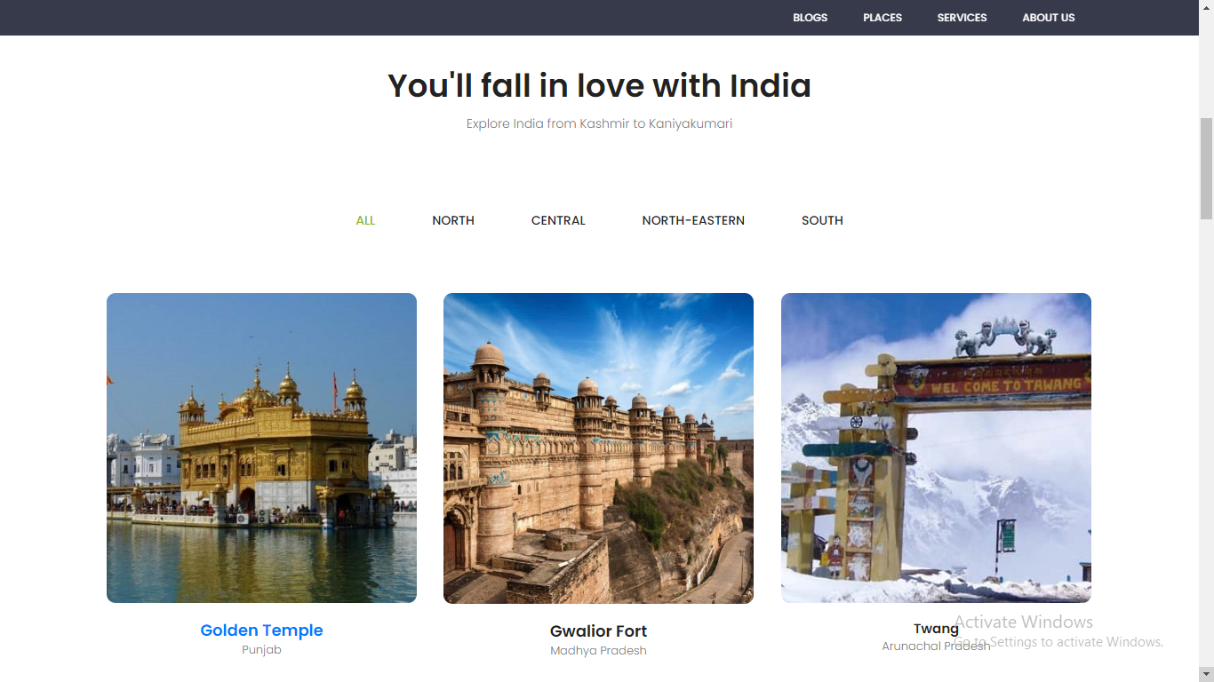

**Practical 4**

**Design a menu (horizontal and vertical) for an app that helps the user in planning their fitness training routine.**

**Code-**

**Vertical-**

**HTML-**

<nav class="vertical-menu-wrapper">

<div class="vertical-menu-logo">

<div>STAY FIT</div>

<span class="open-menu-btn"><hr><hr><hr></span>

</div>

<ul class="vertical-menu">

<li>Workouts</li>

<li>Nutrition</li>

<hr />

<li>Progress</li>

<li>Settings</li>

</ul>

</nav>

<div class="content-wrapper">

<div class="content">

</div>

</div>

**CSS-**

body {

margin: 0;

background: #181824;

font-family: Arial; }

nav {

position: fixed;

width: 100%;

max-width: 300px;

bottom: 0; top: 0;

display: block;

min-height: 300px;

height: 100%;

color: #fff;

opacity: 0.8;

}

nav .vertical-menu hr{

opacity: 0.1;

border-width: 0.5px;

}

nav ul{

width: 90%;

padding-inline-start: 0;

margin: 10px; height: calc(100% - 20px); }

nav .vertical-menu-logo{

padding: 20px;

font-size: 1.3em;

position: relative

}

nav .vertical-menu-logo .open-menu-btn{

width: 30px;

height: max-content;

position: absolute;

display: block;

right: 20px;

top: 0;

bottom: 0;

margin: auto;

cursor: pointer;

}

nav .vertical-menu-logo .open-menu-btn hr{

margin: 5px 0

}

nav li{

list-style: none;

padding: 10px 10px;

cursor: pointer;

}

nav li:hover{

color: rgba(75, 105, 176,1);

}

.content-wrapper{

width: calc(100% - 300px);

height: 100%;

position: fixed;

background: #fff;

left: 300px;

padding: 20px;

}

.closed-menu .content-wrapper{

width: 100%;

left: 50px;

}

.closed-menu .vertical-menu-wrapper .vertical-menu-logo div{

margin-left: -100px;

}

.closed-menu .vertical-menu-wrapper .vertical-menu-logo .open-menu-btn{

left: 7px;

right: 100%;

}

.closed-menu .vertical-menu-wrapper ul,.closed-menu .vertical-menu-wrapper hr{

margin-left: -300px;

}

.content-wrapper{

background: #ebebeb;

}

.content{

width: 90%;

min-height: 90%;

background: #fff;

border-radius: 10px;

padding: 30px;

}

**Output -**

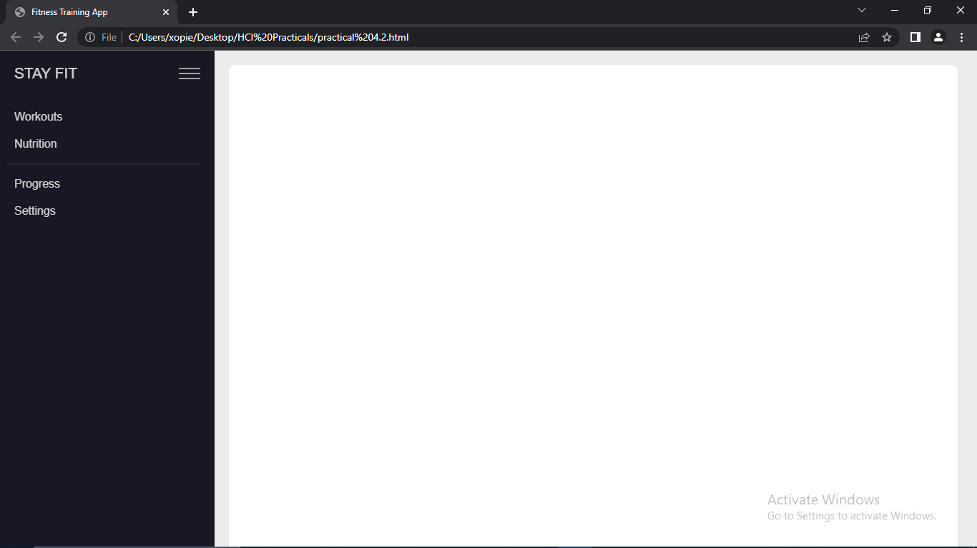

**Horizontal-**

<!DOCTYPE html>

<html>

<head>

<title>Fitness Training App</title>

<style>

body {

margin: 0;

background: #181824;

font-family: Arial;

}

nav {

position: fixed;

width: 100%;

height: 50px;

display: flex;

justify-content: space-between;

align-items: center;

color: #d8d8ff;

padding: 0 20px;

background-color: #333;

}

nav .horizontal-menu-logo {

font-size: 1.3em;

}

nav ul {

display: flex;

list-style: none;

margin: 0;

}

nav li {

margin: 0 10px;

cursor: pointer;

padding-inline-start: 20px;

}

nav li:hover {

color: rgba(75, 105, 176,1);

}

.content-wrapper{

width: 100%;

height: calc(100% - 50px);

position: fixed;

background: #fff;

top: 50px;

padding: 20px;

}

.content{

width: 90%;

min-height: 90%;

background: #ebebeb;

border-radius: 10px;

padding: 30px;

}

</style>

</head>

<body>

<nav class="horizontal-menu-wrapper">

<div class="horizontal-menu-logo">STAY FIT</div>

<ul class="horizontal-menu">

<li>Workouts</li>

<li>Nutrition</li>

<li>Progress</li>

<li>Settings</li>

</ul>

</nav>

<div class="content-wrapper">

<div class="content">

</div>

</div>

</body>

</html>

**Output-**

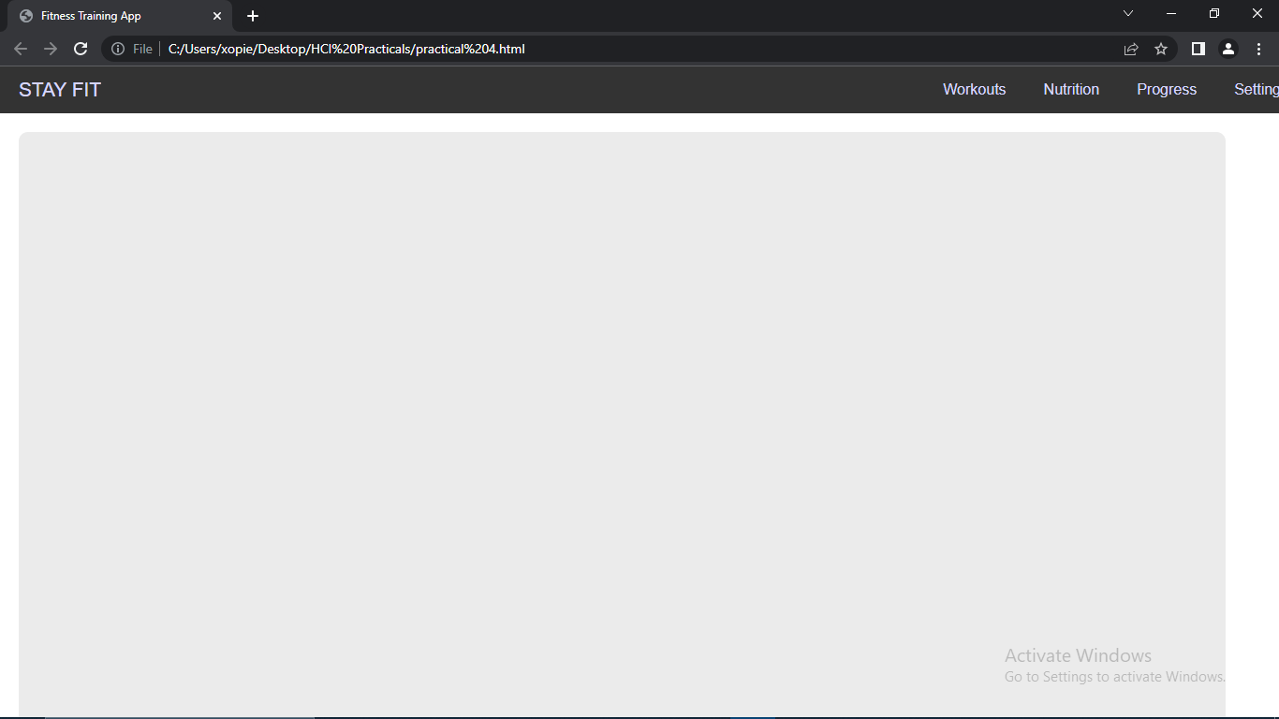

**Practical 5**

**Design appropriate icons pertaining to a particular domain say for example Wedding Cards**

**Code-**

<meta charset="UTF-8">

<meta name="viewport" content="width=device-width, initial-scale=1.0">

<title>Wedding Invite</title>

<link rel="stylesheet" href="practical5.css">

<body>

<div class="container">

<p class="header">April 10th, 2023 Paris, France</p>

<p class="header1">~We drew a map on your bedroom ceiling~</p>

<i class="fas fa-heart heart-icon"></i>

<div class="main-section">

<div class="three-sectins">

<div class="img-container">

<img src="https://i.top4top.io/p_2238dobqo1.png" alt="bride">

</div>

<p class="header2">Taylor Swift</p>

<div class="title-container">

<span class="special"></span>

<p class="header3">bride</p>

<span class="special"></span>

</div>

<p class="details">Lorem ipsum dolor sit amet,consectetur adi pisi cing elit,sed do eiusmod tempor exercitationemut labore et dolore magna aliqua. Ut enim ad consequatur quis nostrud exercitation ullamc...</p>

</div>

<div class="date-container three-sectins">

<div class="section">

<div class="time">

<div class="number">7</div>

<span></span>

<p class="header4">months</p>

</div>

<div class="time">

<div class="number">13</div>

<span></span>

<p class="header4">days</p>

</div>

</div>

<p class="header4">.....Until we get married!</p>

</div>

<div class="three-sectins">

<div class="img-container">

<img src="https://www.pngmart.com/files/7/Groom-PNG-Clipart.png" alt="groom">

</div>

<p class="header2">Joe Alwyn</p>

<div class="title-container">

<span class="special"></span>

<p class="header3">groom</p>

<span class="special"></span>

</div>

<p class="details">Lorem ipsum dolor sit amet,consectetur adi pisi cing elit,sed do eiusmod tempor exercitationemut labore et dolore magna aliqua. Ut enim ad consequatur quis nostrud exercitation ullamc...</p>

</div>

</div>

</div>

</body>

**CSS-**

:root {

--main-color: #7e8d99;

--main-color2: #f05f75;

--main-color3: #dfdee3;

}

* {

padding: 0;

margin: 0;

box-sizing: border-box;

}

body {

font-family: Arial, Helvetica, sans-serif;

background-image: url("https://k.top4top.io/p_2239wh92a1.jpg");

background-repeat: no-repeat;

background-size: cover;

}

.container {

background-color: #fff;

display: flex;

flex-direction: column;

align-items: center;

border: 1px solid #ccc;

padding: 20px;

width: 90%;

max-width: 900px;

margin: 35px auto;

}

.header {

letter-spacing: 5px;

font-size: 20px;

text-shadow: 0 0 black;

margin-bottom: 10px;

}

.header1 {

color: var(--main-color, #7e8d99);

font-size: 12px;

margin-bottom: 20px;

text-transform: uppercase;

}

.details {

color: var(--main-color, #7e8d99);

font-size: 11px;

margin-bottom: 20px;

}

.heart-icon {

color: var(--main-color, #7e8d99);

margin-top: 10px;

font-size: 25px;

}

.heart-icon:hover {

color: var(--main-color2, #f05f75);

}

.main-section {

display: flex;

padding: 0 10px;

flex-wrap: wrap;

align-items: center;

justify-content: center;

}

.three-sectins {

display: flex;

flex-direction: column;

align-items: center;

justify-content: center;

text-align: center;

flex: 1;

max-width: 300px;

padding: 3px;

margin-left: 10px;

margin-right: 10px;

}

.img-container::before ,

.img-container::after {

content: "";

position: absolute;

right: 50%;

transform: translateX(50%);

border: 7px solid;

}

.img-container::before {

top: 100%;

border-color: #7e8d99 transparent transparent;

}

.img-container {

border: 1px solid var(--main-color, #7e8d99);

border-radius: 50%;

padding: 8px 3px 3px;

position: relative;

margin-bottom: 30px;

}

.img-container::after {

top: 99%;

border-color: #fff transparent transparent;

}

img {

width: 100px;

height: 100px;

aspect-ratio: 1;

border-radius: 50%;

}

.header2 {

color: var(--main-color2, #f05f75);

text-transform: uppercase;

font-size: 36px;

margin-bottom: 20px;

}

.title-container {

display: flex;

align-items: center;

width: 100%;

}

span {

display: block;

height: 1px;

background-color: #eee;

margin-bottom: 20px;

}

.special {

width: 50%;

background-color: var(--main-color3, #dfdee3);

}

.header3 {

text-transform: uppercase;

text-shadow: 0 0 grey;

color: var(--main-color, #7e8d99);

font-size: 10px;

margin-bottom: 20px;

margin-left: 10px;

margin-right: 10px;

}

.section {

display: flex;

align-items: center;

justify-content: center;

width: 100%;

justify-content: space-evenly;

}

.time {

border: 1px solid var(--main-color3, #dfdee3);

text-transform: uppercase;

padding: 10px 15px;

width: 40%;

}

.number {

color: var(--main-color2, #f05f75);

font-size: 30px;

font-weight: bold;

margin-top: 10px;

margin-bottom: 25px;

}

.header4 {

text-transform: uppercase;

color: var(--main-color, #7e8d99);

font-size: 11px;

margin-top: 10px;

margin-bottom: 10px;

}

**Output -**

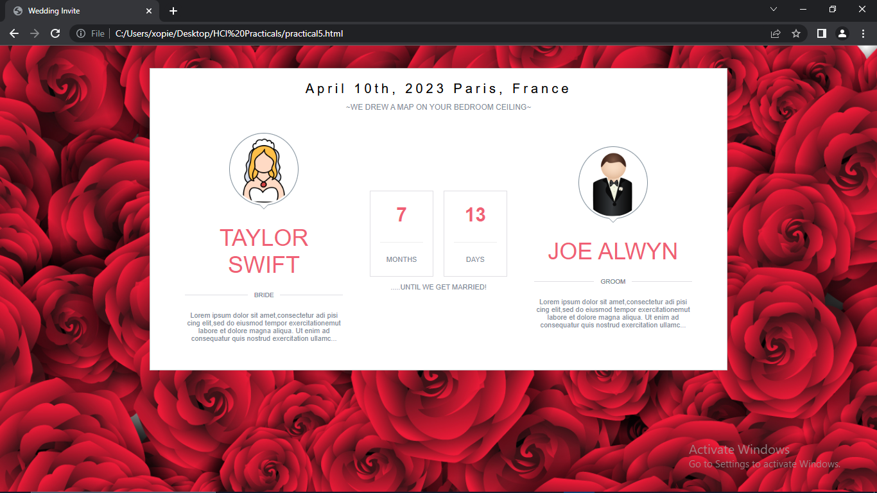

**Practical 6**

**Case Study on Web Interface**

Case Study on Amazon.com-

Amazon is an e-commerce giant with a user base of over 200 million people worldwide. The company’s website is the primary platform for buying products and services, making it essential that the User Interface (UI), User Experience (UX), and Human-Computer Interaction (HCI) are of high quality. In this case study, we will review the UI, UX, and HCI of the Amazon website, identifying areas of strengths and weaknesses.

UI Critique:

Amazon's UI is one of the company's strengths. The website's design is consistent throughout, making it easy for users to navigate. The website's layout is simple, with clear categories and a search bar on the homepage. The color scheme is also well thought out, with the use of white, grey, and black giving the website a professional and modern look. The use of icons and images is consistent and appropriate, making it easy for users to identify products and services.

However, there are a few areas of improvement that can be made to Amazon's UI. For instance, the website's font size is relatively small, making it difficult for some users to read. Also, the search bar could be more prominent, especially for first-time users who may not be familiar with the website's layout. Additionally, Amazon could consider adding a drop-down menu to the search bar to make it easier for users to filter their search results.

UX Critique:

Amazon's UX is generally good, with the company's focus on customer satisfaction and convenience evident in the website's design. The website's navigation is intuitive, with categories, filters, and a search bar making it easy for users to find products. The product pages are also well-designed, with detailed descriptions, multiple images, and customer reviews, making it easier for users to make informed purchase decisions.

However, there are still areas of improvement that can be made to Amazon's UX. For example, the website's load time can be slow at times, leading to frustration for users. Additionally, the website's checkout process can be improved by simplifying the number of steps involved, reducing the number of pages users have to navigate through.

HCI Critique:

Amazon's HCI is one of its strengths, with the company's use of technology making it easier for users to navigate the website. The website's use of predictive search makes it easy for users to find products, while its use of personalization technology ensures that users are presented with products and services relevant to them.

However, there are still areas of improvement that can be made to Amazon's HCI. For example, the website's voice search feature could be improved to make it more accurate and effective. Additionally, the company could consider adding a chatbot feature to the website, enabling users to get immediate assistance when needed.

In conclusion, Amazon's website is generally well-designed, with a few areas of improvement in UI, UX, and HCI. The company should continue to focus on customer satisfaction and convenience, making sure that users can easily navigate the website and find the products and services they need. By addressing the issues outlined in this case study, Amazon can enhance the user experience and maintain its position as a leading e-commerce platform.

**Practical 7**

**Case Study on Mobile App Interface**

Case Study on Zomato app-

Zomato is an online food ordering and delivery platform that allows users to order food from local restaurants. With over 100 million registered users, the app's User Interface (UI), User Experience (UX), and Human-Computer Interaction (HCI) are critical to its success. In this case study, we will review the UI, UX, and HCI of the Zomato app, identifying areas of strengths and weaknesses.

UI Critique:

Zomato's UI is visually appealing, with a modern design that uses bright colors and icons to create a fun and playful look. The app's layout is straightforward, with clear categories and a search bar on the homepage. The use of images is also well thought out, with high-quality food images used to showcase restaurant menus.

However, there are a few areas of improvement that can be made to Zomato's UI. For instance, the app's font size can be small at times, making it difficult for some users to read. The use of multiple colors on some screens can also make the app appear cluttered, while the use of some icons can be unclear, leading to confusion for some users.

UX Critique:

Zomato's UX is generally good, with the app designed to make the food ordering process as seamless as possible. The app's navigation is intuitive, with clear categories and filters that make it easy for users to find restaurants and food items. The app's search bar is also effective, with predictive search and auto-suggestions that help users find the food they want quickly.

However, there are still areas of improvement that can be made to Zomato's UX. For example, the app's load time can be slow at times, leading to frustration for users. The checkout process can also be improved, with some users finding it difficult to navigate, especially when ordering from multiple restaurants. Additionally, the app could benefit from the ability to save payment methods and addresses, making it easier for users to place repeat orders.

HCI Critique:

Zomato's HCI is one of its strengths, with the app's use of technology making it easier for users to navigate the app. The app's use of personalization technology ensures that users are presented with restaurants and food items relevant to their preferences, while its use of location technology ensures that users are presented with options that are near them.

However, there are still areas of improvement that can be made to Zomato's HCI. For example, the app's voice search feature could be improved to make it more accurate and effective. Additionally, the company could consider adding a chatbot feature to the app, enabling users to get immediate assistance when needed.

In conclusion, Zomato's app is generally well-designed, with a few areas of improvement in UI, UX, and HCI. The company should continue to focus on customer satisfaction and convenience, making sure that users can easily navigate the app and find the food they want. By addressing the issues outlined in this case study, Zomato can enhance the user experience and maintain its position as a leading food ordering and delivery platform.

**Practical 8**

**Case Study on Desktop App Interface**

Case Study on Adobe Reader Desktop app-

Adobe Reader is a desktop application that allows users to view, print, and annotate PDF documents. With over 600 million downloads worldwide, the app's User Interface (UI), User Experience (UX), and Human-Computer Interaction (HCI) are critical to its success. In this case study, we will review the UI, UX, and HCI of the Adobe Reader desktop app, identifying areas of strengths and weaknesses.

UI Critique:

Adobe Reader's UI is well-designed, with a clean and modern look that is easy on the eyes. The app's layout is straightforward, with a menu bar at the top and a navigation pane on the left, making it easy for users to navigate through PDF documents. The use of icons is effective, with clear and recognizable symbols used throughout the app.

However, there are a few areas of improvement that can be made to Adobe Reader's UI. For instance, the app's toolbar can be cluttered, with too many buttons that can overwhelm some users. The use of color can also be improved, with a monochromatic color scheme that can make the app appear dull. Finally, the app's font size can be small, making it difficult for some users to read.

UX Critique:

Adobe Reader's UX is generally good, with the app designed to make the PDF viewing experience as seamless as possible. The app's navigation is intuitive, with clear categories and filters that make it easy for users to find specific pages or sections within a document. The app's search bar is also effective, with predictive search and auto-suggestions that help users find specific keywords or phrases quickly.

However, there are still areas of improvement that can be made to Adobe Reader's UX. For example, the app's load time can be slow at times, leading to frustration for users. The app's zoom functionality can also be improved, with some users finding it difficult to zoom in and out of pages. Finally, the app's annotation tools could benefit from an update, with some users finding them difficult to use or too limited in functionality.

HCI Critique:

Adobe Reader's HCI is one of its strengths, with the app's use of technology making it easier for users to navigate through PDF documents. The app's use of personalization technology ensures that users are presented with PDF documents relevant to their interests, while its use of bookmarking technology ensures that users can quickly access frequently visited pages.

However, there are still areas of improvement that can be made to Adobe Reader's HCI. For example, the app's accessibility features could be improved, with some users finding it difficult to use the app with assistive technologies. The app's performance could also be improved, with some users experiencing lag or crashes when using the app for extended periods.

In conclusion, Adobe Reader's desktop app is generally well-designed, with a few areas of improvement in UI, UX, and HCI. The company should continue to focus on customer satisfaction and convenience, making sure that users can easily navigate through PDF documents and find the information they need. By addressing the issues outlined in this case study, Adobe can enhance the user experience and maintain its position as a leading PDF viewer.